Cryptex Apk
Tools used for this challenge:
-jadx-gui
-Sublime text

For solving this challenge, I tried to unpack the apk with 7zip and convert the classes.dex to classes.jar, but it didn’t work, the text was unreadable. So, I used jadx-gui:
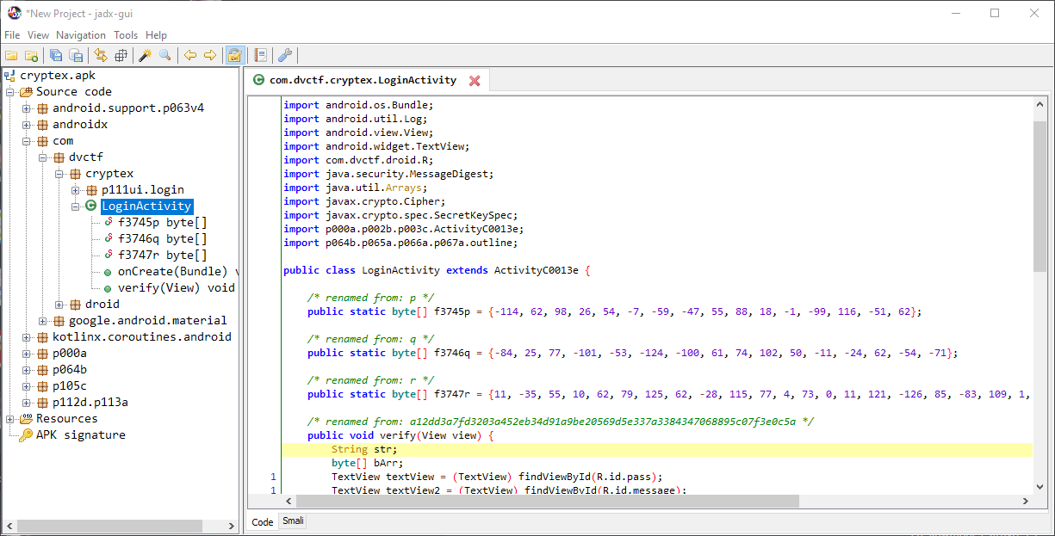
The main class is LoginActivity. Copying, renaming and adapting the code, the class results in this file: github

To summarize the comparison process:
-The password entered by us is encrypted in a hash
-The password is then encrypted in aes. The aes key is created from a value stored
-At the end, a comparison is performed between our password and a stored password, the original password to guess.

So, to retrieve the right password, we have to:
-Take the password stored, used to perform the comparison
-Generate the aes key with the value stored
-Decrypt the password
-Show the hash
-Break the hash

The code used to do that is here

